The results of the weathering grades mapping are summarized in Table 6.2 below, and the comparisons were made in Chart 6.2.
Facade name | Weathering grade (%) |  |  |  |  | Percentage of weathered stones
Facade name | non | slight | moderate | High | extreme | Percentage of weathered stones
Western | 72.20 % | 23.23 % | 3.14 % | 0.42 % | 1.01 % | 27.80%
Southern | 27.39 % | 56.98 % | 10.89 % | 2.66 % | 2.06 % | 72.59%
Eastern | 17.8 % | 51.8 % | 18.6 % | 7.8 % | 3.9 % | 82.10%
northern | 26.13 % | 48.77 % | 16.78 % | 7.02 % | 1.28 % | 73.85%
Average | 35.88% | 45.20% | 12.35% | 4.48% | 2.06% | 64.09 %
Table 6.2 weathering grade percentages
Chart 6.2 comparisons of weathering grade percentages
From the mapping results above, the highest percentage of weathered stones from all grades was found to be in the eastern side by 82.10%, followed by the northern and southern by close percentages (73.85%, 72.95%), the lowest percentage was in the western side by 27.80%. An average of 64.09% of Saint Nicholas Cathedral stones have lost some of its original volume due to deferent weathering process.

The western façade which has relatively very low percentage of weathered stones (27.80%), worth a look. its low percentage can be explained by taking in account the direction of the façade, which is opposite to the direction of sea breeze, and maybe this side had more attention along ages, as it’s the main side, and most of art works are placed on it.
The southern façade has a percentage of 72.59% of weathered stones from all grades most of them are slightly weathered 56.98%, as a result of many possibilities, one of them is the humid marine environment, and salt action which plays the main role of weathering in the whole building.
The eastern façade has the highest percentage of weathered stones 82.10%, and also has the highest percentage of extremely weathered (3.90%), highly weathered (7.80%) and the moderately weathered stones (18.60%), as a direct result of facing the sea which means that it’s receiving the highest portion of salts throughout sea breeze.
The northern façade has a percentage of 73.85% weathered stones, 7.02% are highly weathered, 16.78% moderately weathered and 48.77% are slightly weathered stones. The same reasons can be said about what causes weathering at this façade, but its believed that biological weathering operates at this façade more than it dose at the other façade of the cathedral.

Weathering rate
Figure 6.9 below shows the weathering rate samples sites around the Cathedral, the measured weathering rates on each site are presented in table 6.3. Weathering rate was measured in millimeter per hundred years (mm 100 a-1).
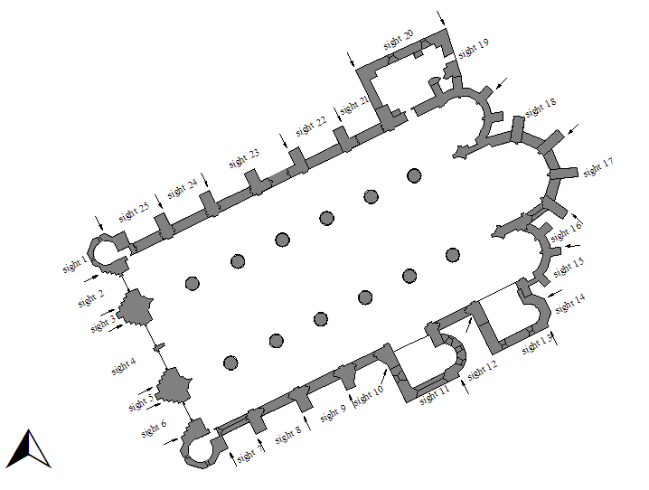
Figure 6.9 shows the sampling sites around Cathedral (Enlart 1987)

Site No. | weathering rate  (mm 100 a-1) | Standard deviation | Site No. | weathering rate  (mm 100 a-1) | Standard deviation
1 | 4.01 | 0.87 | 14 | total loss | total loss
2 | 2.12 | 0.67 | 15 | 7.36 | 1.99
3 | 5.59 | 1.13 | 16 | 6.37 | 1.62
4 | 1.05 | 0.35 | 17 | 4.76 | 0.76
5 | 3.15 | 0.98 | 18 | 9.08 | 1.70
6 | 1.46 | 0.55 | 19 | 12.09 | 4.60
7 | 5.64 | 1.01 | 20 | 10.59 | 1.45
8 | 6.66 | 2.07 | 21 | 6.79 | 3.52
9 | 7.19 | 2.18 | 22 | 3.22 | 1.36
10 | 4.70 | 1.08 | 23 | 3.1 | 1.20
11 | 8.90 | 1.18 | 24 | 2.5 | 0.66
12 | 7.50 | 2.38 | 25 | 4.21 | 2.60
13 | 10.73 | 2.33
Table 6.3 weathering rate averages in each sampling site around the Cathedral
The Quantitative values of the weathering rate above show that, as the sample site becomes more perpendicular to the sea shore, the weathering rate value increases. A clear example of this, is site No. 14, were the depth of the surface recession was so high that the available instruments could not measure it (at least more than 15cm), so the term “total loss” was used to describe it.
The highest weathering rate values were measured in sites 19 (12.09mm100a-1), 13 (10.73mm100a-1) and 20 (10.59mm100a-1) respectively, all of them are perpendicular to seashore and sea breeze main direction. The average weathering rate of the whole building was calculated and found to be 6.54mm100a-1 with a standard deviation value of 3.07.

Physical and mechanical properties
Specific weight (unit weight) and specific gravity (relative density)
Results of the tested sample from the two types of samples are presented below in tables 6.4 and 6.5.
Sample No. | Dry unit weight  (γ_{d}) (kN/m³) | Saturated unit weight (γ_{s}) (kN/m3) | Bulk specific gravity (δ) | apparent specific gravity (δ_{r})
No.1-1 | 18.49 | 20.217 | 1.92 | 2.339
No.1-2 | 17.852 | 20.131 | 1.786 | 2.313
No.1-3 | 19.491 | 21.334 | 1.927 | 2.356
No.1-4 | 18.276 | 20.002 | 1.897 | 2.312
Average | 18.53 | 20.42 | 1.88 | 2.33
Standard deviation | 0.70 | 0.62 | 0.07 | 0.02
Table 6.4 unit weight and specific gravity values of tested samples of No.1 type and there average

Sample No. | Dry unit weight  (γ_{d}) (kN/m³) | Saturated unit weight (γ_{s}) (kN/m3) | Bulk specific gravity (δ) | apparent specific gravity (δ_{r})
No.1-1 | 17.778 | 19.665 | 1.858 | 2.314
No.1-2 | 17.094 | 19.609 | 1.718 | 2.3
No.1-3 | 17.486 | 19.373 | 1.827 | 2.276
No.1-4 | 17.312 | 19.199 | 1.809 | 2.253
Average | 17.42 | 19.46 | 1.80 | 2.29
Standard deviation | 0.29 | 0.22 | 0.06 | 0.03
Table 6.5 unit weight and specific gravity values of tested samples of No.2 type and there average
Water Absorption at Atmospheric Pressure
Results of the tested sample from the two types of samples are presented below in tables 6.6 and 6.7.
Sample No. | Water absorption (%)
No.1-1 | 9.34
No.1-2 | 10.614
No.1-3 | 9.457
No.1-4 | 9.449
Average | 9.72
Standard deviation | 0.70
Table 6.6 water absorption values for the tested samples (No.1 type samples)

Sample No. | Water absorption (%)
No.2-1 | 12.767
No.2-2 | 14.714
No.2-3 | 10.791
No.2-4 | 10.9
Average | 12.29
Standard deviation | 1.96
Table 6.7 water absorption values for the tested samples (No.2 type samples)

According to ASTM C 568 (1990), densities of limestone have been grouped in three categories shown in table 6.8 below:
Category | Density |  | Description
Category | Lb/ft³ | kN/m³ | Description
Category I | 110 | 17.3 | Low
Category II | 135 | 21.2 | Medium
Category III | 160 | 25.1 | High
Table 6.8 Classification of density of limestone

Samples No.1 has an average unit weight of 18.53 kN/m3, whereas samples No.2 have a unit weight of 17.42 kN/m3. Even though No.1 has higher density values than No.1, but both of sample types is in the same value range according to the classification above, and they can be classified as limestones with low density.
Water absorption values can be used to classify density of limestone according to ASTM C 568 (1990); table 6.9 contains three classes of density according to water absorption values.
Absorption % | description
12 | Low density
7.5 | Medium density
3 | High density
Table 6.9 Classification of density of limestone according to water absorption

According to table 6.9, both sample types can be classified as low density limestone.

Compressive strength test
Sample No. | Compressive strength
Sample No. | MPa
No.1,a | 30.67
No.1,b | 31.35
Average | 31.01
Table 6.10 compressive strength test results (samples type No.1)
Figure.6.10 compressive strength results for samples (No.1,a and No.1,b)(KUDEB 2010)

Sample No. | Compressive strength
Sample No. | MPa
No. 2,a | 17.73
No.2,b | 17.43
average | 17.58
Table 6.11 compressive strength test results (samples type No.2)

Figure.6.11 compressive strength results for samples (No.2,a and No.2,b) (KUDEB 2010)
The grades of compressive strength shown in table 6.13 have been suggested by IAGE (1979).
Term | Strength (MPa)
Very weak | Less than 1.25
Weak | 1.25-5.00
Moderately weak | 5.00-15.50
Moderately strong | 12.50-50
Strong | 50-100
Very strong | 100-200
Extremely strong | Over 200
Table 6.12 classification of compressive strength (IAGE 1979)
According to the classification above both of the sample types No.1 and No.2 can be classified as moderately strong rocks.

Petrographical and chemical analysis
Water soluble salts and conductivity analysis
For the two types of samples, the analysis of their water soluble salts content has been measured. Conductivity of water containing these solved salts has been measured as well. Results are provided in Table 6.14.
Sample No. | salts
Sample No. | Cl⁻ | SO₄²⁻ | CO₃²⁻ | NO³⁻ | PO₄³⁻ | Conductivity (μS/cm)
No. 1 | ± | - | - | ± | - | 123
No. 2 | ± | - | - | ± | - | 113
- : Not existing, ±: Existing /Not existing, + Existing in low, %. ++ : Existing, +++ : high existence,++++ : very high existence
Table 6.13 results of Water soluble salts and conductivity analysis (KUDEB 2010)
According to the results above, none of the two samples include (Cl⁻) (SO₄²) (CO₃²⁻) (NO³⁻) (PO₄³⁻).
Loss on ignition and acid Insoluble residue analysis
Results of losses on ignition (LOI) and Insoluble residue (IR) for the two samples are presented in the table below (Table 6.15), % of CaCO₃ also shown.
Sample  No. | Loss on ignition % |  |  | Acid Insoluble residue %
Sample  No. | water | 550º C | CaCO₃ | soluble | Insoluble
No.1 | 5.09 | 0.41 | 94.32 | 99.76 | 0.24
No.2 | 2.34 | 0.43 | 74.24 | 75.92 | 24.08
Table 6.14 results of LOI and IR analysis (KUDEB 2010)
The determination of carbonate content can be used to classify chemical-grade limestone or chemical purity of lime stone (Table 6.16).
No | Percentage of CaCO3 | Category
1 | > 98.5 | Very high purity
2 | 97.0 – 98.5 | High purity
3 | 93.5-97.0 | Medium purity
4 | 85.0 – 93.5 | Low purity
5 | < 85.0 | impure
Table 6.15 British Geological Scheme for the classification of limestone by purity (Hallsworth et al. 1999)
The classification of chemical-grade lime stone by CaCO3 content does not take account of all variations in chemical composition. The mineral impurities commonly found in limestone include quartz, dolomite, clays, pyrite and other iron and manganese minerals (Hallsworth et al. 1999).
Characterization of both carbonate and non-carbonate mineralogy can be initially undertaken by investigation of acid insoluble residue.
According to the classification in table 6.16, the sample No.1 can be classified as medium pure limestone, and sample No. 2 can be classified as impure limestone.

Petrographical analysis
Visual stereo microscope analysis
After the samples were treated with acid, the silicate aggregates (which were not a part of the reactions) were screened with a thin layer and viewed under stereo microscope. Figures 6.12 & 6.13:
Sample No.1 was not analyzed due to the extremely low insoluble residue value 0.24%, Sample No. 2 showed that aggregates having size between 125-500 μm contains seldom feldspar, very small amount 1% of volcanic rocks, very small amount 1% of clay, and small amount 1-2% of chlorite, and the remaining amount was quarts.
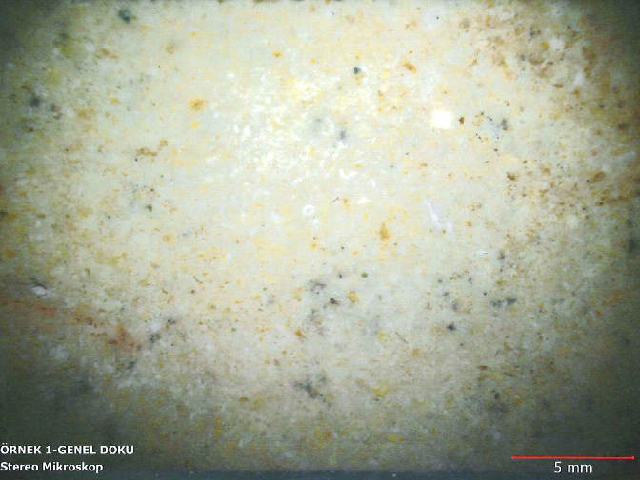
Figure 6.12, general view of sample No.1 using Stereo Microscope (KUDEB 2010)
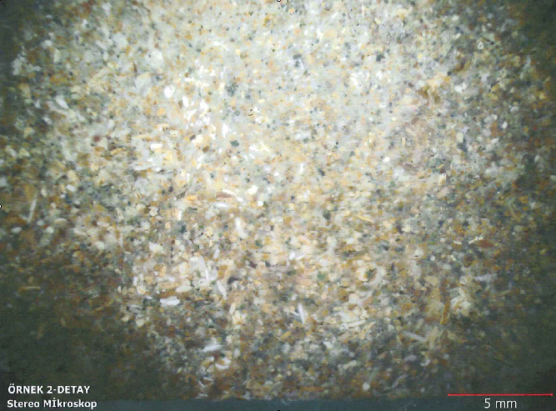
Figure 6.13 general view of sample No.2 using Stereo Microscope (KUDEB 2010)
Polarized microscope
The samples were prepared to this test by coating a thin slice of stone with epoxy, and then viewed under polarized microscope, figures 6.14 & 6.15. Samples were classified according to Folk (1962) classification scheme. And also according to Leighton et al. (1962) classification, table 6.17.
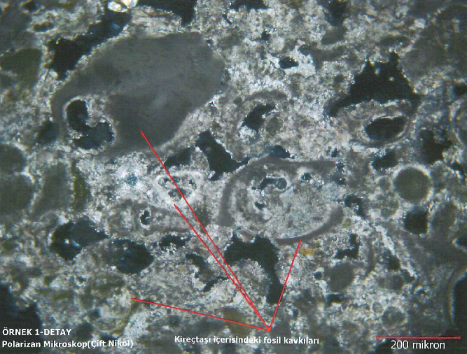
Figure 6.14 Sample No.1 cross sectional view under the polarized microscope. Texture showing fossil fragments. (KUDEB 2010)
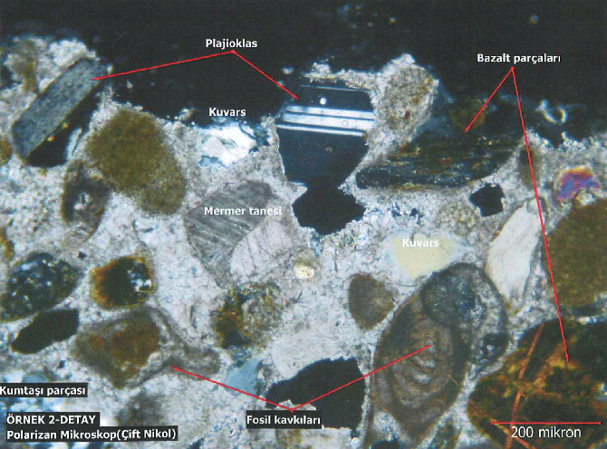
Figure 6.15 sample No.2 cross sectional view under the polarizing microscope. The parts marked in the figure are (fosil Kavkilari) fossils, (mermer tanesi) marble, (kuvars) quarts, (bazalt) basalt, (plajioklas) plagioclase (KUDEB 2010)
Sample No | Lithological Name ª | Engineering Classification ^{b}
No.1 | Biopelsparite | Argillaceous limestone
No.2 | Clayey biomicrite  with quartz clast | limestone
Table 6.16 Classification of limestone samples (No.1 and No.2)\
^{a:} According to Folk (1962), ^{b}: According to Leighton et al. (1962)

CONCLUSIONS
All historical limestone monuments in Famagusta’s walled city are affected by weathering. Studies on the weathering of limestone were carried out for 683 years old building “Saint Nicholas Cathedral (built in 1327)” as it was the case study.
All weathering rates that have been measured and determined for the study case can be used as a standard values for the historical buildings which have been established in the same era, because they share the same environmental conditions and were built using similar construction methods.
Studies on the weathering of limestone included; the evaluation of weathering state for the Cathedral in means of weathering forms and causes, a stone- by- stone investigation of discoloration stages and weathering grades by the means of monument mapping; in situ quantitative measurements of weathering rates. Physical, chemical, mechanical and Petrographical properties of some limestone samples obtained from the Cathedral were carried out in laboratories. For better understanding of weathering causes, the environmental conditions of Famagusta were investigated using the available data provided by deferent sources like the TRNC metrological department. The study stepped forward and provided a detailed definitions and explanations for everything related with modern preservation technology, and also the study recommended a group of methods, terms and procedures to be considered and carried out in any future restoration project.
The most common forms of weathering at Saint Nicholas Cathedral was investigated, here they are, without any order:
Loss of stone material, Relief (R), Alveolar weathering (Ra),
Discoloration/ deposits, biological colonization to crust (B-C), Microbiological colonization to dark-colored crust tracing the surface (Bi-dkC),
Discoloration/ deposits, biological colonization (B), colonization by higher plants (Bh),
Discoloration/ deposits, soiling to crust (I-C), soiling by paricles from the atmosphere to dark- colored crust tracing the surface (pI-dkC),
Discoloration/ deposits, discoloration (D), coloration (Dc),
Discoloration/ deposits, Loose salt deposits to crust (E-C), Efflorescences to light-colored crust tracing the surface (Ee-hkC).
The monument mapping method has proved again to be a reliable and efficient phenomenological procedure for characterisation, documentation, evaluation and rating of stone weathering at monuments. For the investigated building, monument mapping results showed that an average of 57.43% of the Cathedral’s stones have lost there original colour, and discoloration percentages were increasing in the order north>east>south>west at the building. It has been observed that 64.09% of stones were weathered (lost some/ most of its original volume), weathered stones percentages were increasing in the order east>north>south>>>west.
Quantitative observations of depth of surface recession (weathering rate) average value for the whole building were found to be 6.54mm 100a-1, and values were increasing in the order east>north>south> west at the Cathedral.
Using the petrographical analysis of the stone samples the two types of natural building stones used in the building were classified by means of engineering classification to argillaceous limestone and limestone.
Throughout physical and chemical tests and environmental investigations it has been found that the main causes of limestone weathering in the Cathedral was, the type of used building stones and there properties. It has been found that two types of limestone were used in the Cathedral, and according to the laboratory physical tests, both of them were found to have low unit weight (18.53kN/m3 & 17.42kN/m3). Since two limestone types was either medium pure limestone (CaCO3 = 94.32%) or impure limestone (CaCO3=74.24%), they contain some amount of fossils and other materials, thing that affect the stones performance against the weathering parameters, and also affect compressive strength values especially for samples from type No.2 which has larger percentage of fossils in its texture, compressive strength was measured for the two sample types (No.1 = 31.01MPa), (No.2 = 17.58MPa), and was classified according to these values to be moderately strong rocks.
From the Insoluble residue results for tested Limestone samples, it has been found that they have high solubility water and weak acid solutions, (for No.1, IR=99.76% & for No.2 IR=75.92%), limestone solubility leads to dissolution of stone surfaces and in the presence of saline moistures it leads to salt weathering.
The relatively high temperature in summer day time, and the high temperature deference between day and night times along the year, in the presence of the humidity, plays a vital role in weathering of stone building throughout the continues wetting-drying cycles.
The sunshine path over the building has an effect of increasing the humidity levels and moisture content of the stones on northern facade.
Due to the Cathedrals place near to coast side, the winds which blowing from sea direction is on of the main causes of weathering located in the eastern-southern sides of the Cathedral, that is a result of the sea breeze phenomena which driving hot air from sea surface to the cooler land in day time, this air carries the saline sea spray while blowing to the land and to the stones surface as well.
The high concentration of (PM10) due to Sahara dusts in the month of February and March, helping in the soiling effect.

RECOMMENDATIONS
The researcher recommended future researchers to conduct a more detailed test for analyzing the mechanical behavior which in tern may lead to the structural analysis of the cathedral. Conducting the foundation frequencies of the structure may give an idea about building response to moderate sized earthquakes.
Future research should conduct mapping of the cathedral by the means of weathering forms, because it may give an accurate values of the most common weathering forms which in tern specify the weathering causes.
The researcher recommends future studies to conduct the same tests for different case studies (buildings by mountains, inside land, etc) to compare results to achieve better understanding of the effect of environment.
Based on the weathering state analysis of the site, the mapping results, weathering rate values and building stone type, the following conservation measures are recommended:
Cleaning: the first action to be conducted in the site is to clean it to remove dirt, higher plants, biological colonization and microbiological colonization. For this purpose both mechanical and chemical methods should be adopted. However, for determining the method to be used, it is important to consider terms in chapter three of this study and also to test it thoroughly.
Desalination: second action is trying to remove the water-soluble salts from stone pours, in the preparation for farther protection by coatings for example.
Consolidation: due to prevailing weathering factors affecting the site, high portion of stones lost its strength and became soft; therefore, consolidants should be applied to reestablish the weakened strength. To determine what type of consolidant that can be used, a series of testing procedures should
be devised.
Restoration: Restoration should be based on respect for existing material and on the logical interpretation of all available evidence, so that the place is consistent with its earlier form and meaning. It should only be carried out if the cultural heritage value of the place is recovered or revealed by the process. The restoration process typically involves reassembly and reinstatement and may involve the removal of accretions.
Replacement: actions like restoration and consolidation doesn’t sound to be realistic when its related with some of the stones which have lost most of its volume. The only realistic solution is to remove weathered stones and place a new stones. The added stones should match the original stones properties like density, void ratio, unit weight, specific gravity, strength; ets. (Values are given in this study), because any change in the stone properties can cause unfavorable effects, for example deferent expansion and shrinkage ratios can cause serious cracks to other stones.
Weathering grade mapping results in this study can give important information’s to what to be done for each stone. The following preservation plane can be recommended according to mapping results:
  - For stones which have no visible damage, intervention is not necessary,
  - Slightly weathered stones: restoration under consideration.
  - Moderately weathered stones: restoration, consolidation and partial replacement under consideration.
  - Highly weathered stones: restoration, consolidation and partial replacement under consideration.
  - Extremely weathered stones: partial replacement/ replacement.
Surface coating: is the next step after cleaning, restoration, consolidation and replacement, is applying the suitable surface coatings to all the stones, and since water proved to be the enemy number one for limestone in Saint Nicholas Cathedral, its recommended to use water repellents intensively, once water intrusion to stone stops, then no salt crystallization can take place, no organisms can grow and high portion of chemical reactions can be avoided.
Finally; some preventive conservation measures can be used like protective shelters which is essential for the case of eastern façade facing seacoast, its expected that it can reduce acceleration of weathering in that side when those shelters inhibit sea spay to directly strike the building.

